**Well Come to Automation Testing**

In this tutorial you will learn how to automate any website by Testing Framework. This tutorial base on the Selenium TesNg framework.

1)Set Up the default framework setup for any project

2)Standard architecture for Automation Framework

3) Standard scripting level

4) Slandered data driven architecture (Next Tutorials)

5) Test case Execution Strategy (Next Tutorials)

6) Customization Report (Next Tutorials)

7) Jankins and Selenium Grids (Next Tutorials)

Note: Read documents thoroughly any. Documentation is still under process. This is not the final version .For ant concern reach out to me @(mchowdhury891@outlook.com)

**Installation of JDK**

To install JDK you need to download JDK, Unzip the folder

Tools

1. Windows 10
2. JDK 1.8

## 1. Advanced System Settings

Type advanced system settings in the search box (beside the Windows start button), clicks View advanced system settings.

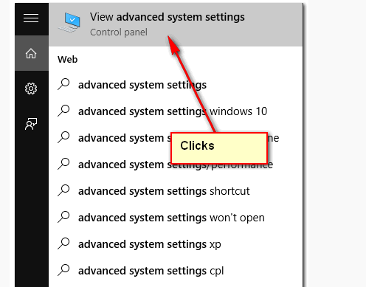

## 2. Environment Variables

Select Advance tab, clicks Environment Variables

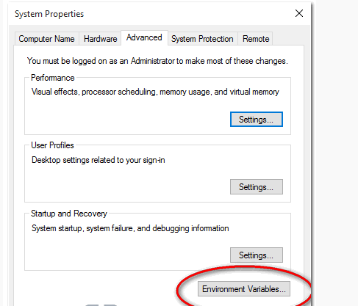

## 3. Add JAVA_HOME

In System variables, add a new JAVA_HOME variable and point it to the JDK installed folder.

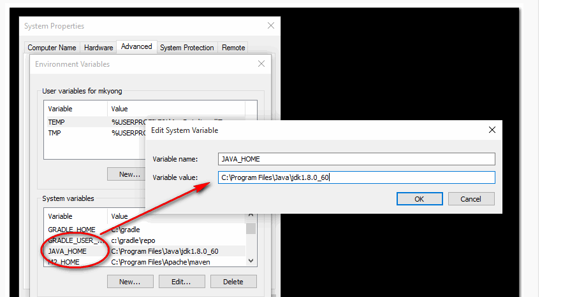

**Note**  
**Don’t include the** \bin folder, just the JDK path. For example

1. **Correct – C:\Program Files\Java\jdk1.8.0_60**
2. Wrong – C:\Program Files\Java\jdk1.8.0_60\bin

## 4. Update PATH

In System variables, find PATH, clicks edit and append this %JAVA_HOME%\bin to the end.

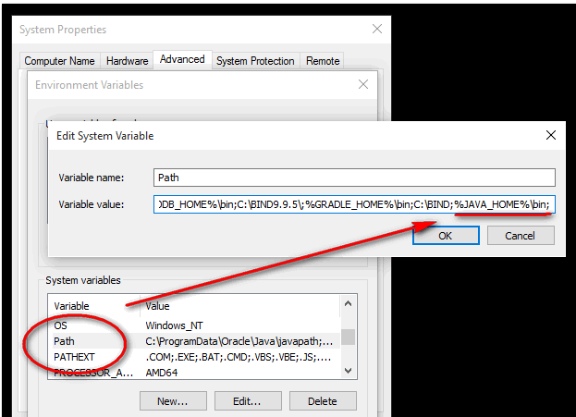

*P.S Puts the JAVA_HOME\bin in PATH make the Java’s commands are accessible from everywhere.*

## 5. Test

Open a command prompt, type:

C:\Users\mjoy>java -versionjava version "1.8.0_60"Java(TM) SE Runtime Environment (build 1.8.0_60-b27)Java HotSpot(TM) 64-Bit Server VM (build 25.60-b23, mixed mode)

**Installation Maven for windows**

To install [Apache Maven](http://maven.apache.org/) on Windows, you just need to download the Maven’s zip file, and Unzip it to the directory you wish to install, and configure the Windows environment variables.

Tools Used :

1. JDK 1.7
2. Maven 3.2.2
3. Windows 8

1)JDK and JAVA_HOME installation

Make sure JDK is installed, and “**JAVA_HOME**” variable is added as Windows environment variable.

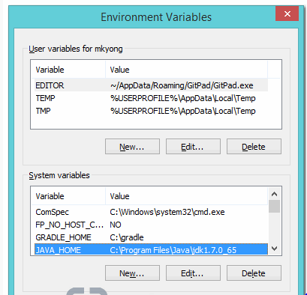

## 2. Download Apache Maven

Visit [Maven official website](http://maven.apache.org/download.cgi), download the Maven zip file, for example : apache-maven-3.2.2-bin.zip. Unzip it to the folder you want to install Maven.

Assume you unzip to this folder – C:\Program Files\Apache\maven

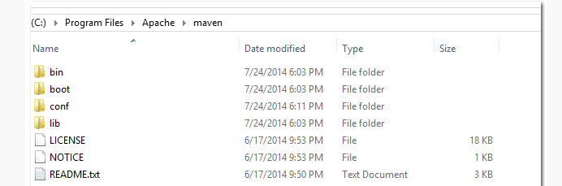

**Note**  
**That’s all, just folders and files, installation is NOT required.**

## 3. Add M2_HOME and MAVEN_HOME

Add both M2_HOME and MAVEN_HOME variables in the Windows environment, and point it to your Maven folder.

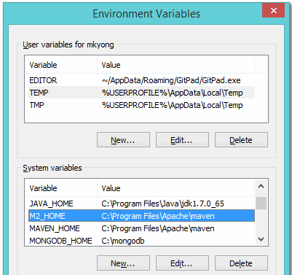

**M2_HOME or MAVEN_HOME**  
**Maven document said add M2_HOME only, but some programs still reference Maven folder with MAVEN_HOME, so, it’s safer to add both**

## 4. Add To PATH

Update PATH variable, append Maven bin folder – %M2_HOME%\bin, so that you can run the Maven’s command everywhere.

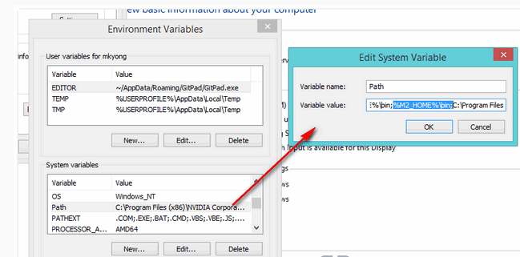

## 5. Verification

Done, to verify it, run mvn –version in the command prompt.

C:\Users\mjoy>mvn -versionApache Maven 3.2.2 (45f7c06d68e745d05611f7fd14efb6594181933e; 2014-06-17T21:51:42+08:00)Maven home: C:\Program Files\Apache\mavenJava version: 1.7.0_65, vendor: Oracle CorporationJava home: C:\Program Files\Java\jdk1.7.0_65\jreDefault locale: en_US, platform encoding: Cp1252

**Maven Installation**

Pre-Request: Maven Home valuable is already set Up in Environment variable (How to Install go to Page)

**Steps**

1) Open **Ellipse**

2) Click on Install new software under Helps

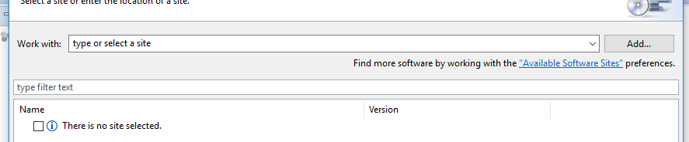

3)Click on ADD

4)Enter Name: Maven

5)Ente URL: According to Release Note (Example-<http://download.eclipse.org/technology/m2e/releases>). You can check from <http://www.eclipse.org/m2e/>

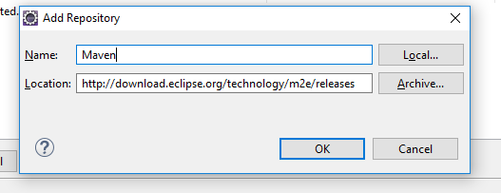

6)Click on OK

7)Select the Maven Integration for Eclipse and Click Next

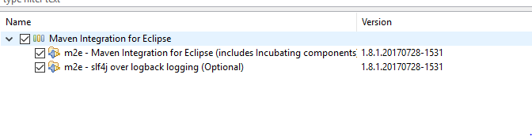

Note: It will calculate the dependency time may take some time

8) click Next after review the software which you are installing

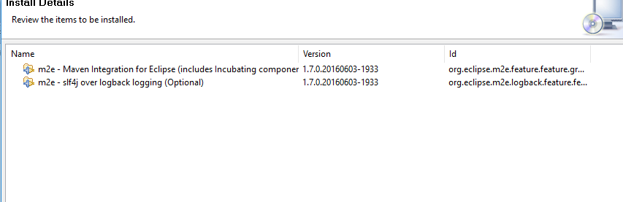

9) Accept the terms and license agreement and click on Finish

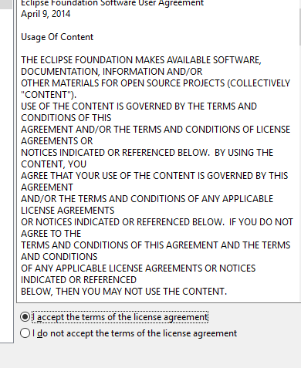

10)It will install maven and ask for restart the Eclipse. Restart Eclipse

11) Create a new project

File ->New ->Others->Maven->Maven Project

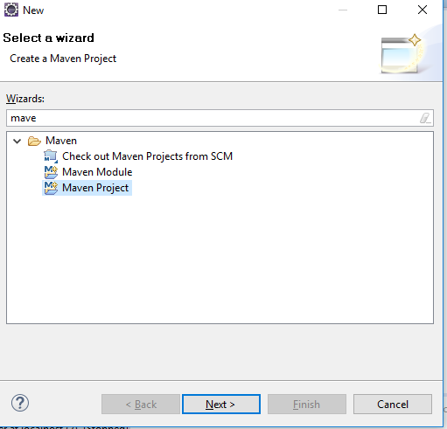

12)Use default work location and Select the current location

13 ) Select quick start project and Click on Next

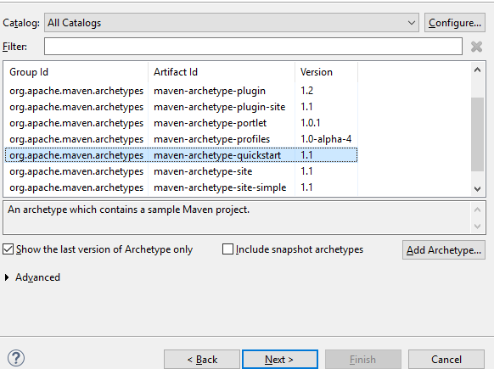

14)Enter Group ID: Example Automation, Artifice ID: Example Automation and Keep other things remain same.

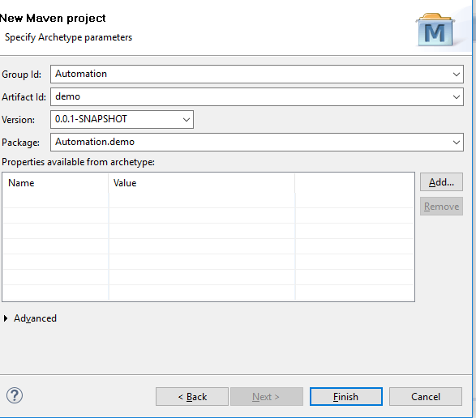

15)If you are getting bellow error don't be afraid and keep patient and follow the steps as it is mention

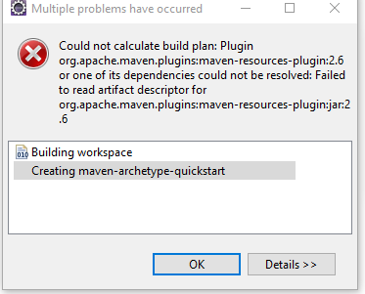 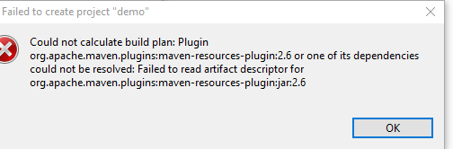

15) Open folder **conf**  where you downloaded the Apache Maven (For My case: F:\selenium\apache-maven\apache-maven-3.5.0\conf)

16)Setting xml file

17)Add this Entry and save

* <localRepository>F:\selenium\apache-maven\apache-maven-3.5.0\repository</localRepository>

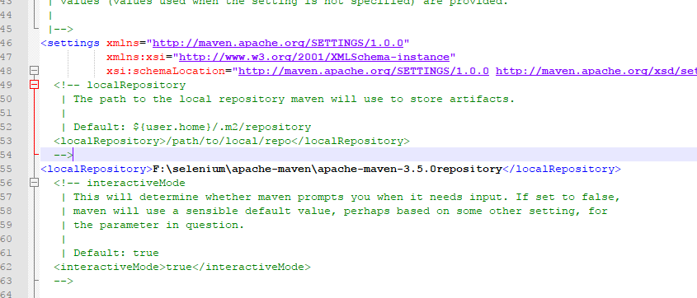

Step 18) Open Window/Reference on Eclipse.

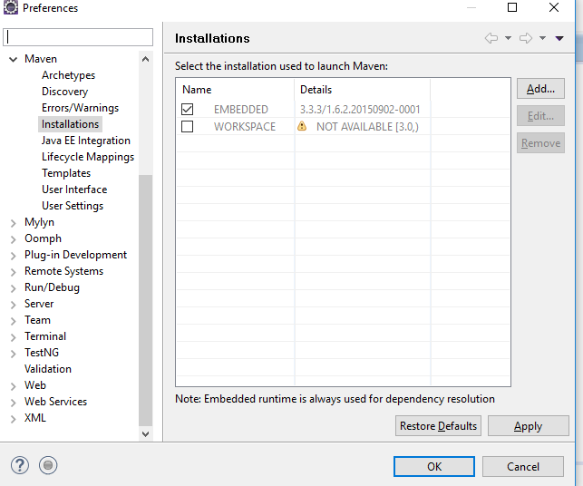

19) Click on ADD

20) Enter the directory where maven is installed (This should be the MAVEN HOME )

21) Installation Name Will Auto populate Click on Finished

22)Select Apache Maven and click on Apply

23) Declare the position of the Maven configuration file which was changed last time.

24)Click on User setting and upload the Setting XML file

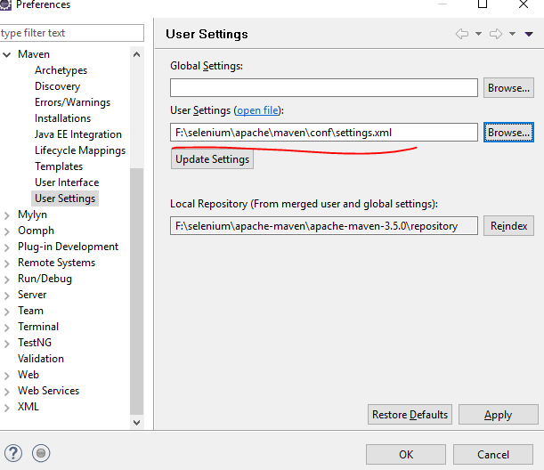

25)Click on Update and OK

26) Check Updating Dependency Maven. After updating update the project

Right Click on the Project ->Maven->Update Project

28)Below folder structure will Create

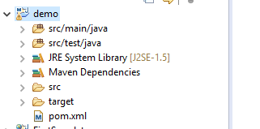

**Your Maven Installation is done. Now don't sits idle start working.**

**Over View of Maven Project**

1)**prom.xml:** Impotent file in maven which will malintents all the dependency to the project all over the groups .and make the project in same dependency we use prom.xml file.

1.a) Adding Dependency to the project :

Steps

a) Open prom.xml

b) Navigate to dependency

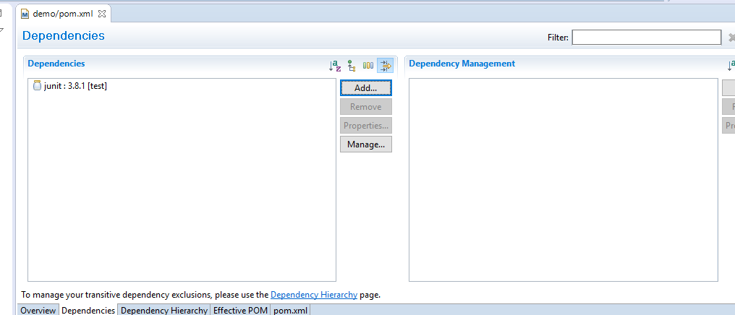

c)click on ADD

d)Enter Group ID and Artifact ID

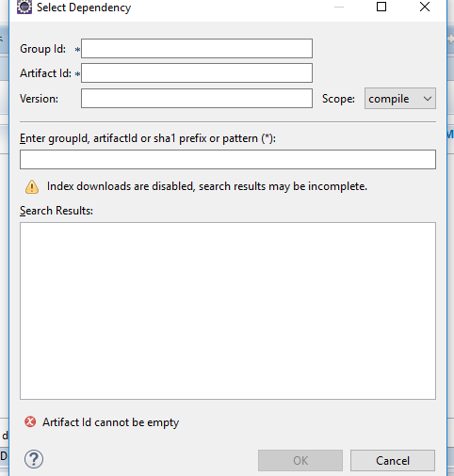

Example: Adding Selenium Dependency

Search Dependency in google ()

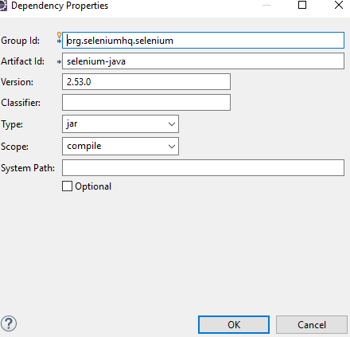

Click on OK and save the project. It will download selenium mentioned version

e) Check on Maven Dependency. It will add all the Jar it self

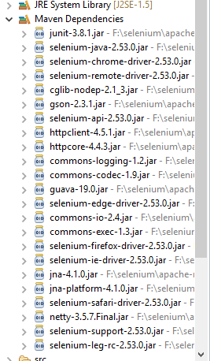

2) **src/main/java:** Contains all the base java classes which will be called during the teste case execution

3)**src/test/java:** Contains all the Test classes for the automation

**Selenium Framework**

Pre-Request: You have Installed Maven

1) Created Simple Maven Project In Eclipse (For Refence Got to Page -)

2) Add All the Dependency. Dependency are

A) Selenium-Java

B) Test Ng (http://testng.org/doc/maven.html)

C) Apache Poi (https://mvnrepository.com/artifact/org.apache.poi/poi/3.16)

3) Create **src/main/java:** Contains all the base java classes which will be called during the teste case execution. Create all the common package which will be frequently and the methods which will be called during the any functionality

A) Creating a Common Package Name: common. Which will contain all the driver initiation,

Will Contains Class : DriverFactory, strartDriver, Constaints and BaseTest

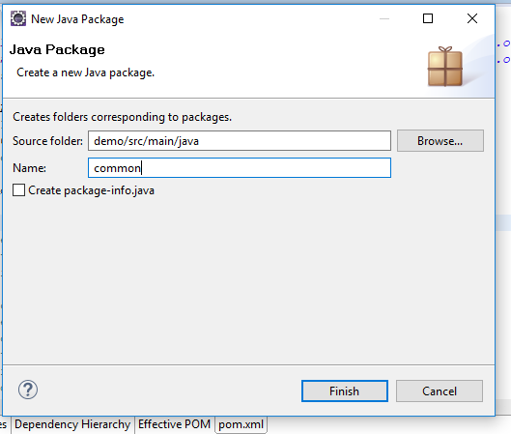

Class 1)

**Constraint Class:** Which will Store All the Constraints

Code:

//////

package common;

public class Constraints {

public static final String IE_BROWSER = "ixplore";

public static final String FF_BROWSER = "Firefox";

public static final String CHROME_BROWSER = "chrome";

public static final String MISSING_PAGE_MSG = "page is missing";

}

////

Class 2)

**DriverFactory :** Which Will contains and setup all the driver details

Note: As of now I don’t have maven dependency for the Driver Binary location. Means we can add the driver in maven dependency later we can use it. Later will discuss on this. Currently I have downloaded my driver in my system and using the driver by setting the system property

Code :

///////

package common;

package common;

import org.openqa.selenium.WebDriver;

import org.openqa.selenium.chrome.ChromeDriver;

import org.openqa.selenium.firefox.FirefoxDriver;

import org.openqa.selenium.ie.InternetExplorerDriver;

public class DriverFactory {

private static String BrowserDetails =null;

public static String getBrowserDetails() {

return BrowserDetails;

}

private WebDriver webDriver=null;

public WebDriver getDriver(String driver){

try{

if(driver.equalsIgnoreCase(Constraints.CHROME_BROWSER)){

System.setProperty("webdriver.chrome.driver","F:\\selenium\\chromedriver_win32\\chromedriver.exe");

webDriver= new ChromeDriver();

BrowserDetails= Constraints.CHROME_BROWSER;

}

else if (driver.equalsIgnoreCase(Constraints.FF_BROWSER)){

System.setProperty("webdriver.gecko.driver","F:\\selenium\\chromedriver_win32\\chromedriver.exe");

webDriver= new FirefoxDriver();

BrowserDetails= Constraints.FF_BROWSER;

}

else if (driver.equalsIgnoreCase(Constraints.IE_BROWSER)){

System.setProperty("webdriver.ie.driver", "F:\\selenium\\IEDriverServer_x64_2.52.0\\IEDriverServer.exe");

webDriver= new InternetExplorerDriver();

BrowserDetails= Constraints.IE_BROWSER;

}

else {

System.setProperty("webdriver.gecko.driver","F:\\selenium\\geckodriver\\geckodriver.exe");

webDriver= new FirefoxDriver();

BrowserDetails= Constraints.FF_BROWSER;

}

return webDriver;

}

catch(Exception a){

System.out.println("Error oocured in Driver factory ");

System.out.println(a.getMessage());

return null;

}

}

}

///

**Class 3**

StartDriver: Whis is a @BeforeClass means it will execute before the the test test cases starts execution . It will take the brwoser and the URL and inititate the driver and open the page it will be called by the each test case to inittiate the precondition

It containts alsi @Afterclass, means it will executre the post condition after the test. Currently it is having only closing the browsers

Code:

package common;

import org.openqa.selenium.WebDriver;

import org.testng.annotations.AfterClass;

import org.testng.annotations.BeforeClass;

import org.testng.annotations.Parameters;

public class StartDriver {

private DriverFactory driver=null;

protected WebDriver webDriver=null;

public WebDriver getWebDriver() {

return webDriver;

}

protected String URL=null;

public String getURL() {

return URL;

}

public void setURL(String uRL) {

URL = uRL;

}

@BeforeClass

@Parameters({"browsername","url"})

public void IntiateDriver(String browsername,String url){

System.out.println("Entering the Initiate Driver method ");

setURL(url);

driver =new DriverFactory();

webDriver=driver.getDriver(browsername);

webDriver.navigate().to(getURL());

System.out.println("Driver is initiated "+webDriver.getTitle());

}

@AfterClass

public void QuitDriver(){

webDriver.close();

webDriver.quit();

}

}

**Class 4**

Base: It is base class for each and every object method present in java folder under src .it will initiate he XPATHs for all the page. Its having all the common methods which will be calling frequently by the methods for performing operation.main methods is **initlize()**  which will initilize the XPATH file

Code:

package common;

import java.io.FileInputStream;

import java.io.FileNotFoundException;

import java.io.IOException;

import java.util.Properties;

import org.openqa.selenium.By;

import org.openqa.selenium.WebDriver;

import org.openqa.selenium.WebElement;

import org.openqa.selenium.support.ui.ExpectedConditions;

import org.openqa.selenium.support.ui.WebDriverWait;

import org.testng.Assert;

public class Base {

public Base(WebDriver driver, String url){

setWebdriver(driver);

setUrl(url);

initlize();

}

protected WebElement webelement;

protected Properties openpage;

public WebElement getWebelement() {

return webelement;

}

/*public void setWebelement(WebElement webelement) {

this.webelement = webelement;

}*/

protected static String url;

public String getUrl() {

return url;

}

public void setUrl(String url) {

this.url = url;

}

protected WebDriver webdriver;

public WebDriver getWebdriver() {

return webdriver;

}

public void setWebdriver(WebDriver webdriver) {

this.webdriver = webdriver;

}

//*******************************

//Intilize property file

public void initlize(){

try {

openpage = new Properties();

//openpage.load(new FileInputStream(System.getProperty("F:\\selenium\\AutomationWorkspeace\\demo\\src\\test\\java\\xPath\\openPage.properties")));

openpage.load(new FileInputStream(System.getProperty("user.dir").concat("/src/test/java/xpth/openPage.properties")));

} catch (FileNotFoundException e) {

System.out.println("Error occured in initilize method");

System.out.println(e.getMessage());

} catch (IOException e) {

// TODO Auto-generated catch block

System.out.println("Error occured in initilize method");

System.out.println(e.getMessage());

}

}

//**********************************************************************************

// All common methods

public void waitforElimentIsDisplay(String XPATH){

for (int seceond=0;seceond <=30;seceond++){

if(isPresent(By.xpath(XPATH),1)){

break;

}

else {

System.out.println("ELEMENT is Not present ");

System.out.println("STuck in waitforElimentIsDisplay");

}

}

}

public boolean isPresent(By by,int waitTime ){

try{

WebDriverWait wait = new WebDriverWait(webdriver,waitTime);

wait.until(ExpectedConditions.visibilityOfElementLocated(by));

webdriver.findElement(by).isDisplayed();

return true;

}

catch(Exception e){

System.out.println("Problem is in Preseent method");

System.out.println(e.getMessage());

return false;

}

}

public WebElement getObejct(String XPATH){

try {

return webdriver.findElement(By.xpath(XPATH));

} catch (Exception e) {

// TODO: handle exception

System.out.println("Error occured in getObejct");

System.out.println(e.getMessage());

return null;

}

}

public void clickObejct(String XPATH){

waitforElimentIsDisplay(XPATH);

webelement= getObejct(XPATH);

webelement.click();

}

public boolean insertText(String XPATH,String strText){

try {

waitforElimentIsDisplay(XPATH);

webelement = getObejct(XPATH);

if(webelement.isEnabled()&& webelement.isDisplayed()){

if(strText.isEmpty()){

return true;

}

else{

webelement.clear();

webelement.sendKeys(strText);

Thread.sleep(300);

return true;

}

}

else{

return false;

}

} catch (Exception e) {

// TODO: handle exception

System.out.println("Error occured in INsert method");

System.out.println(e.getMessage());

return false;

}

}

/*public boolean asert(String value,String actual,String expected ){

try {

switch(value){

case "compareText":

Assert.assertEquals(actual, expected);

break;

case"containsTextTrue":

Assert.assertTrue(isPresent(By.xpath(expected)));

break;

}

} catch (Exception e) {

// TODO: handle exception

}

}

*/

}

//\*\*\*\*\*\*\*\*\*\*\*\*\*\*\*\*\*\*\*\*\*\*\*\*\*\*\***END of Common package**\*\*\*\*\*\*\*\*\*\*\*\*\*\*\*\*\*\*\*\*\*\*//

4)

**TestNg.xml:** It is a test Ng xml which contains all the test cases which required to be run. Not only test cases you can call the multiple test suits which can contains test cases as well. It contains the base parameter like browser.URL and etc. The main function is it will search test case mention in the test case parameter in the src/test/java and contains the @test annotation. And before the Strat execute the Test class it will search @Beforeclasss and it will execute that first. After running the test cases, it will search for #AfterTest class and will run that class as a post condition

TextNg.xml code below (remined that spelling is correct )

<suite name="basic">

<parameter name="browsername" value="iexplore"/>

<parameter name="url" value="http://www.google.com/"/>

<test name ="openbrowser">

<classes>

<class name="common.Openpage"/>

</classes>

</test>

</suite>

\*\*\*\*\*\*\*\*\*\*\*\*\*\*\*\*\*\*\*\*\*\*\*\*\*\*\*\***END OF TESTNG**\*\*\*\*\*\*\*\*\*\*\*\*\*\*\*\*\*\*\*\*\*\*\*\*\*\*\*\*\*\*\*\*\*\*\*\*\*\*

**Src/test/java:**  the folder contains all the test case class by model wise. Each test cases which needs to be run in testng.xml will be here with @Test annotation. And each class will extends the startDriver class to execute the preconditions and post conditions. And it will contains all the XPATH for each page (you can places and groups as a different folder ).In each test method will have @Test annotation

Example given: Test cases written for Open Gmail from google starting page

Code:

package common;

import org.openqa.selenium.By;

import org.testng.annotations.Test;

import Gmail.basic;

public class Openpage extends StartDriver{

public Openpage(){

super();

}

@Test

public void TC_01(){

Gmail.basic login = new basic(super.webDriver, URL);

System.out.println("print");

if(login.openGmail()){

System.out.println("passed");

}

else{

System.out.println("failed");

}

}

/*public void openpage() {

System.out.println("print");

Base test= new Base(super.webDriver, URL);

test.getWebdriver().findElement(By.linkText("Gmail")).click();

}*/

}

5)XPATH: Write Xpath for each element present in page.To take XPATH from the page follow the steps

1) Crate folder under src/test/jave

A) Right click on src/test/jave->New->Other->search folder->

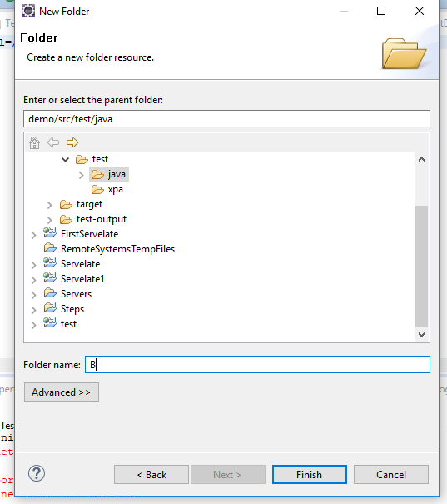

B)Select Normal folder

C)Click on next and enter name

D)Click finish

2) Create a property file

A) Right Click on newly created folder ->New->others->file-Select File

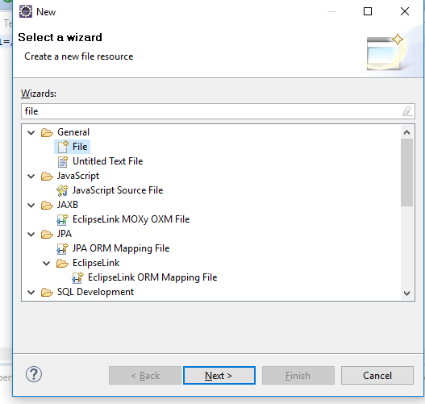

B) Enter name like Openpage.properties

3)Create XPATH on that properties file

A) open the page (<https://www.google.co.in/>) in chrome

B) Click F12 for developer type

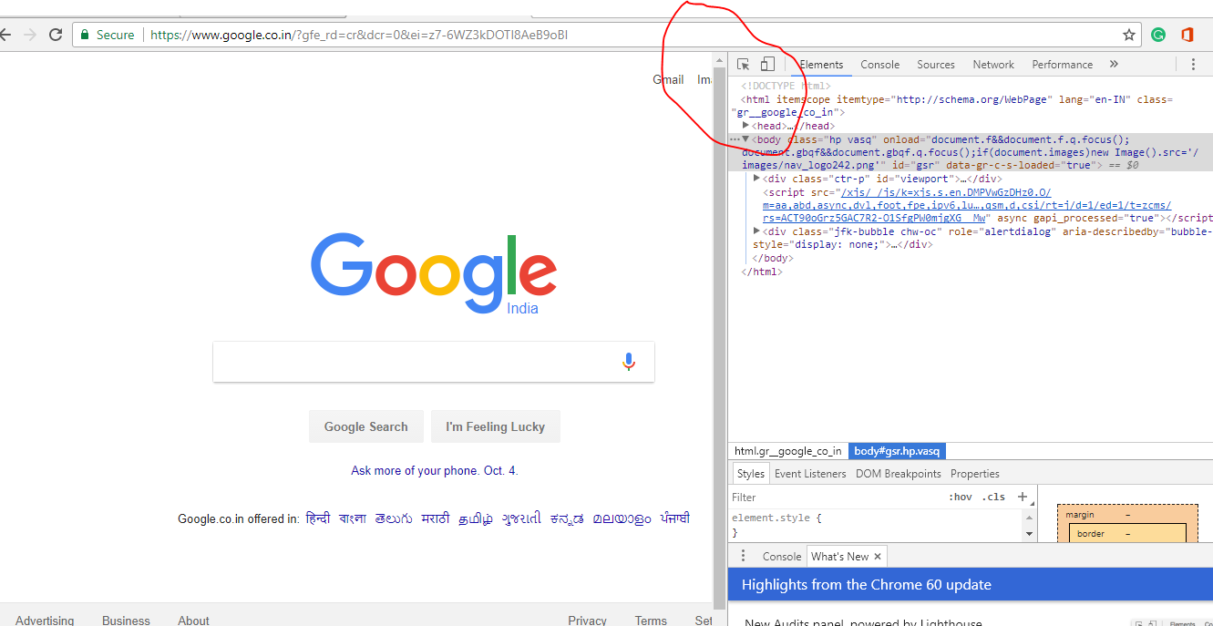

D) Click on inspect element

E) over the mouse on the page for which you want to take the XPATH (Example Gmail)

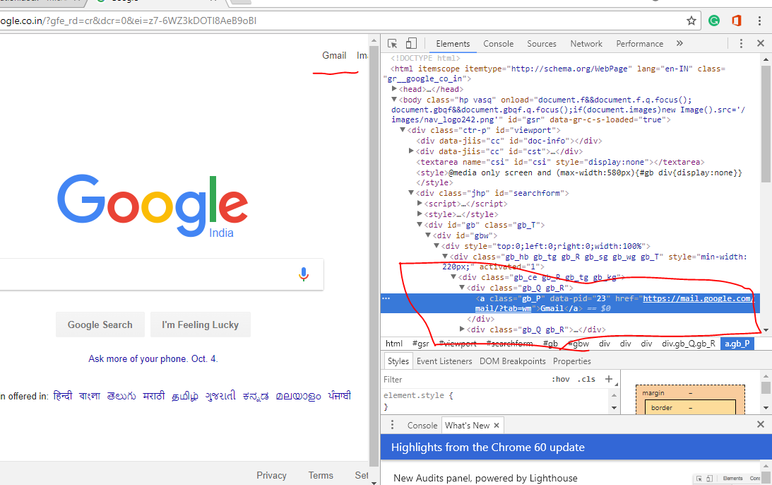

F) go to the Element section, the selected element will show all the details

G) Right Click on it you will get the **Copy** ->**copy XPath**

H) In Property file create a variable and past the XPATH

Sample code for XPATH

click_gmail=//*[@id="gbw"]/div/div/div[1]/div[1]/a